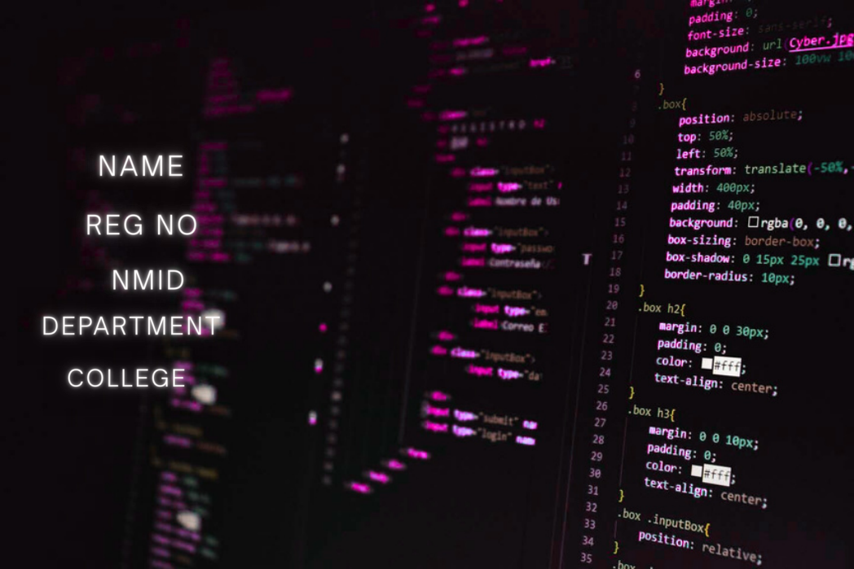

|  |
| --- |
| : **GAYATHRI. S**  : **2428b0266**  : **asbru262428b0266**  : **BSC COMPUTER SCIENCE WITH DATA ANALYTICS**  : **SHRI NEHRU VIDYALAYA COLLEGE OF ARTS AND SCIENCE** |

main+file.pdf-compressed.pdf Page 1 of 12



|  |
| --- |
|  |

main+file.pdf-compressed.pdf Page 2 of 12

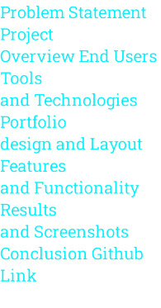

|  |
| --- |
|  |

main+file.pdf-compressed.pdf Page 3 of 12

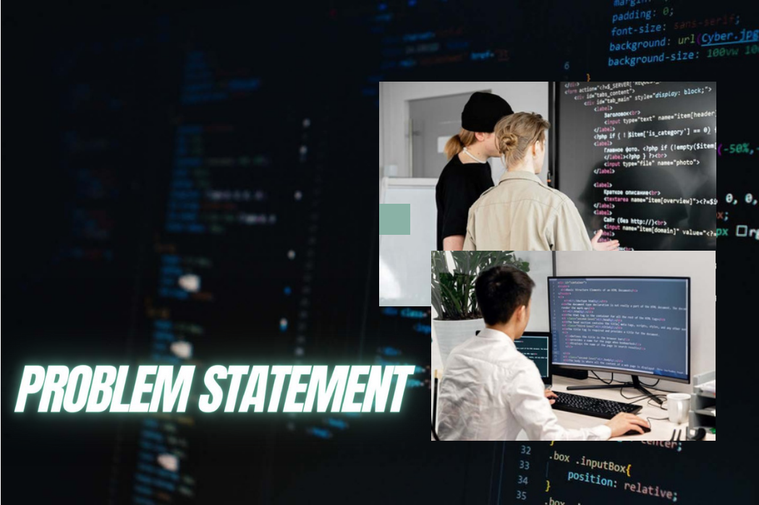

|  |  |  |  |  |  |  |  |  |  |  |  |  |
| --- | --- | --- | --- | --- | --- | --- | --- | --- | --- | --- | --- | --- |
| In the modern digital era, relying only on traditional  resumes is not enough to showcase an individual’s  skills, projects, and achievements. Recruiters and  collaborators often look for an online presence   |  |  |  |  |  |  | | --- | --- | --- | --- | --- | --- | | that | reflects | both | technical | expertise | and |   creativity. Without a personal digital space, it  becomes difficult to stand out in a competitive  field. To overcome this challenge, this project   |  |  |  |  |  |  | | --- | --- | --- | --- | --- | --- | | focuses | on | developing | a | personal | portfolio |   website , providing an organized and professional  platform to present qualifications, certifications,  and projects in an easily accessible manner. |

main+file.pdf-compressed.pdf Page 4 of 12

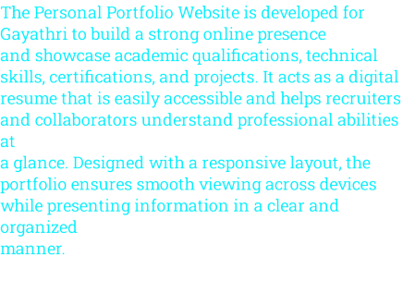

|  |
| --- |
|  |

main+file.pdf-compressed.pdf Page 5 of 12



|  |
| --- |
| **Recruiters and**  **Employers** – to **Peers and**  evaluate skills, **Collaborators** – to  qualifications, and connect for academic  projects for job or professional  opportunities. projects.  **General Audience** –  **Faculty Members and**  anyone interested in  **Evaluators** – to assess  learning more about  technical knowledge  the professional profile  and project work.  of Almas Begam. |

main+file.pdf-compressed.pdf Page 6 of 12

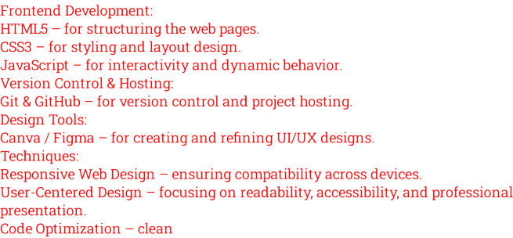

|  |
| --- |
|  |

main+file.pdf-compressed.pdf Page 7 of 12



|  |
| --- |
| ***H o m e P a g e – A b r i e f i n t r o d u c t i o n w i t h n a m e , t i t l e , a n d a p r o f e s s i o n a l***  The portfolio website is designed with a ***t a g l i n e .***  clean and modern layout to ensure ***A b o u t M e – S h o w c a s i n g p e r s o n a l b a c k g r o u n d , e d u c a t i o n , a n d c a r e e r***   ***g o a l s .***  professionalism and user-friendly  ***S k i l l s – H i g h l i g h t i n g t e c h n i c a l a n d s o f t s k i l l s i n a n o r g a n i z e d f o r m a t .***  navigation. The design follows a  ***P r o j e c t s – D i s p l a y i n g a c a d e m i c a n d p e r s o n a l p r o j e c t s w i t h***  responsive web structure, making it ***d e s c r i p t i o n s .***  accessible across desktops, tablets, ***C e r t i f i c a t i o n s – L i s t i n g r e l e v a n t c e r t i f i c a t i o n s a n d a c h i e v e m e n t s .***   ***C o n t a c t S e c t i o n – P r o v i d i n g e m a i l , p h o n e , a n d s o c i a l m e d i a l i n k s f o r***  and mobile devices.  ***e a s y c o m m u n i c a t i o n .*** |

main+file.pdf-compressed.pdf Page 8 of 12



|  |
| --- |
| Responsive Design – Works smoothly on desktop, tablet, and mobile.  Home & About Sections – Introduction, background, and career goals.  Skills & Projects – Showcases technical abilities and academic work.  Certifications – Displays completed certifications and achievements.  Contact Section – Provides email, phone, and social media links.  Easy Navigation – Clean and user-friendly menu system. |

main+file.pdf-compressed.pdf Page 9 of 12

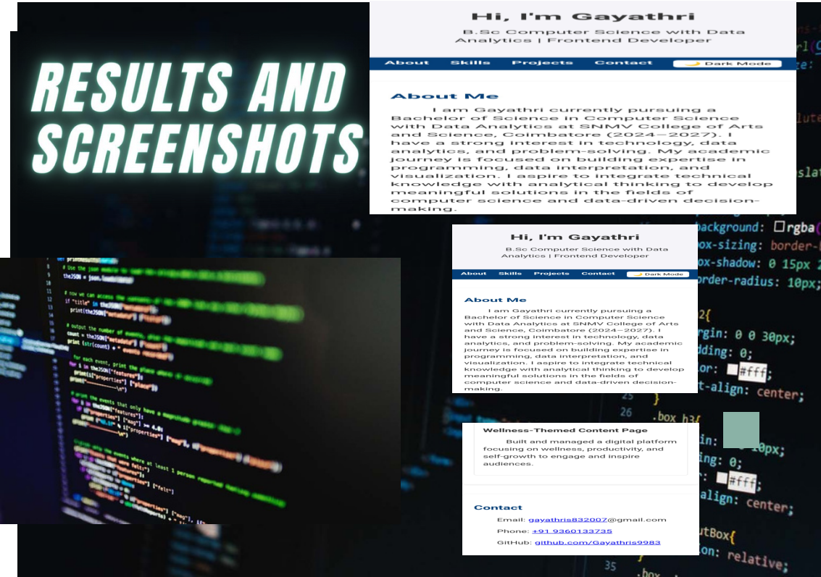

|  |
| --- |
|  |

main+file.pdf-compressed.pdf Page 10 of 12

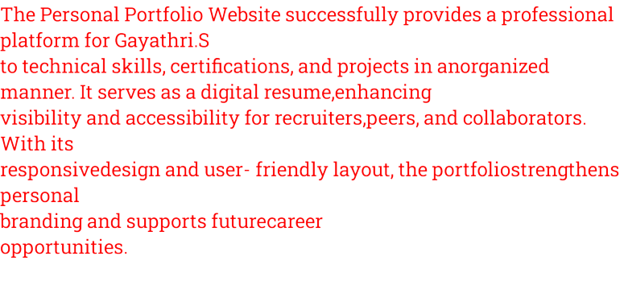

|  |
| --- |
|  |

main+file.pdf-compressed.pdf Page 11 of 12



|  |
| --- |
|  |

main+file.pdf-compressed.pdf Page 12 of 12